COSC 304 Walkthrough

url: <http://localhost/shop/index.jsp>

Arnold test Bobby bobby Candace password Darren pw Beth test

On opening the website, you will see this page with many different links. Normally, a user would first go to the login page to log in to their own account.

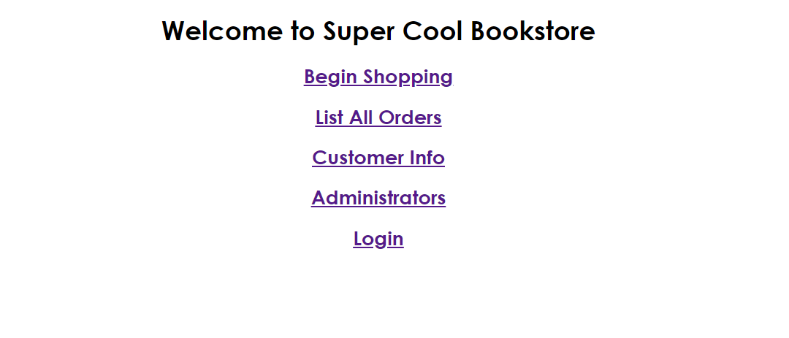

On visiting the login page, the website asks the user to enter their username and password to authenticate. There is also an option for new users to create an account.

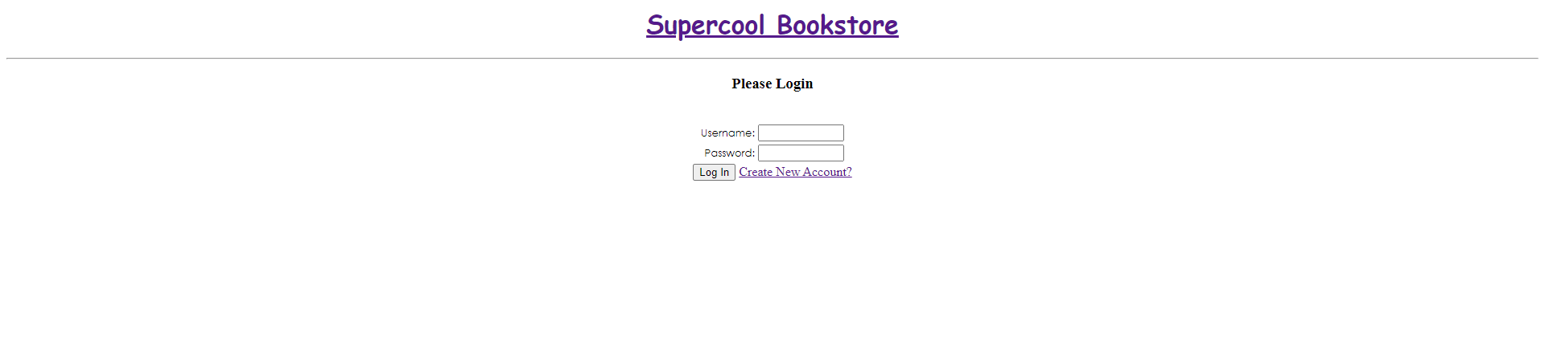

Once the user enters the correct credentials for their account, the user is taken back to the home page and a message is displayed at the bottom of the links showing which account they are logged into.

If a user clicks on the create new account button, they are directed to a page where they can enter the personal information that is required to create an account. The user can set their username and password to whatever they like except they can’t leave any blank fields and can’t have the same username as someone else.

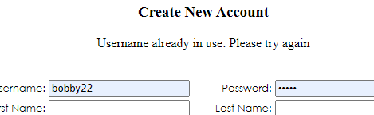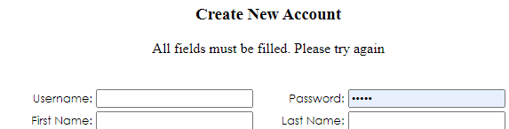

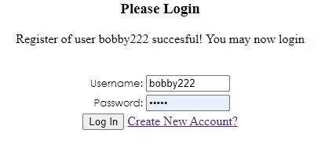

After pressing the create account button at the bottom, the user will be taken back to the login screen where there will be a message displaying if the account has been successfully created. If it has been created, the user can then proceed to log into their new account.

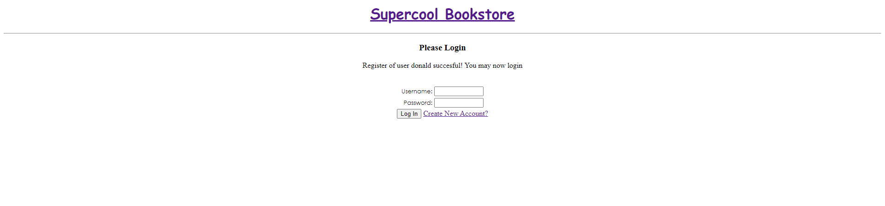



After a user has logged in, the user can click on the ‘Begin Shopping’ link which will take them to the storefront which displays a list of all items. Each item has its own respective category, author and price. There are options on the top of the page to filter through these traits to display only the items you want to see. There is also a search bar on top where you can directly search for a book's name. Next to each product name, there is also an add to cart button to directly add that item to your cart. In the page’s header, you can see the store’s name which can be clicked on to take you back to the home page. There is also an indicator showing you which account you are logged into. Also, recommended products are shown here, which are recently bought products in this case.

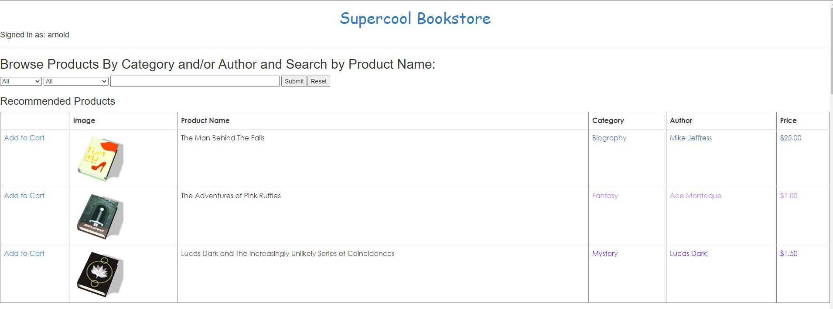

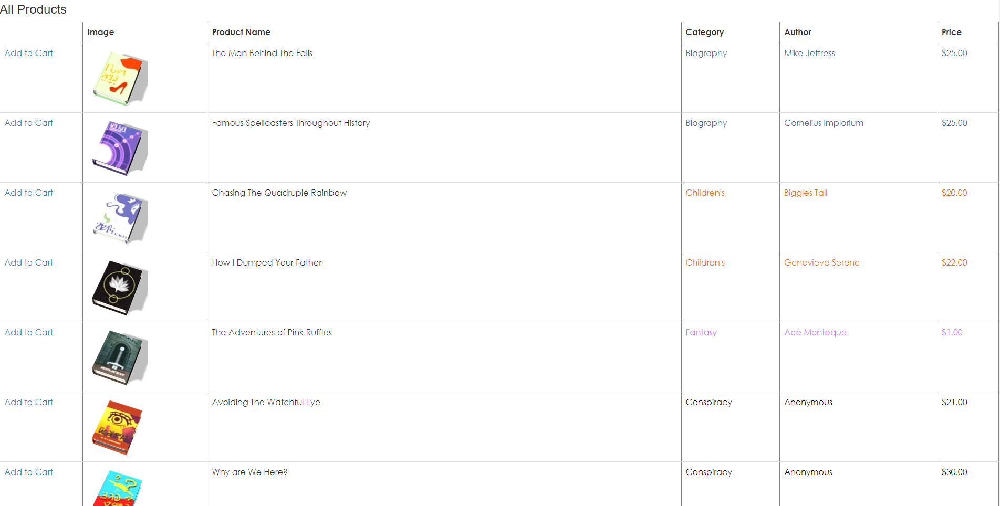

You can sort by author name, category, product name or a mix of multiple/all three

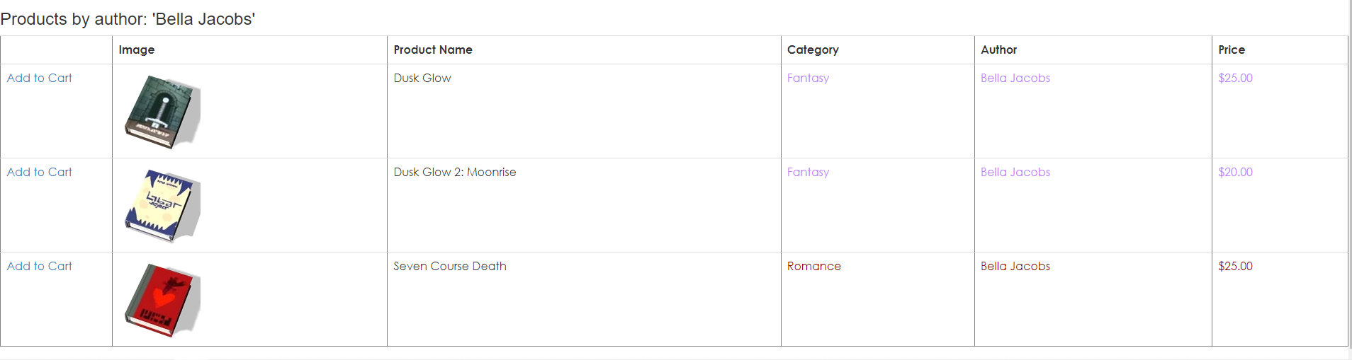

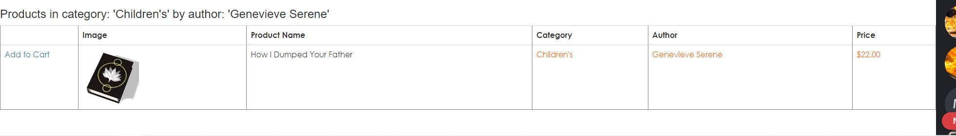

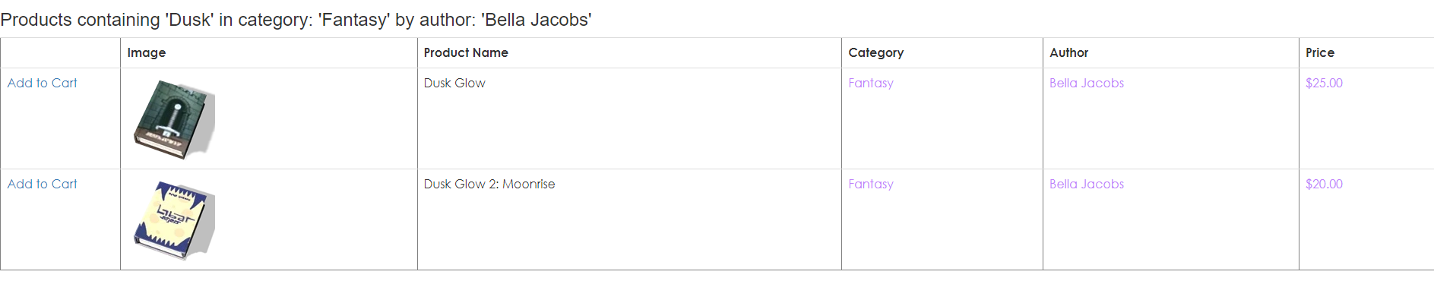

Each product image is also a link. When you click on the name of a particular product, you are taken to the product’s information page. The product page contains the name of the product, an image of the product, the product ID, the price and finally a description of the product.

There are also buttons to add the item to your cart, to return to the product browsing page, and even a button to leave a review.

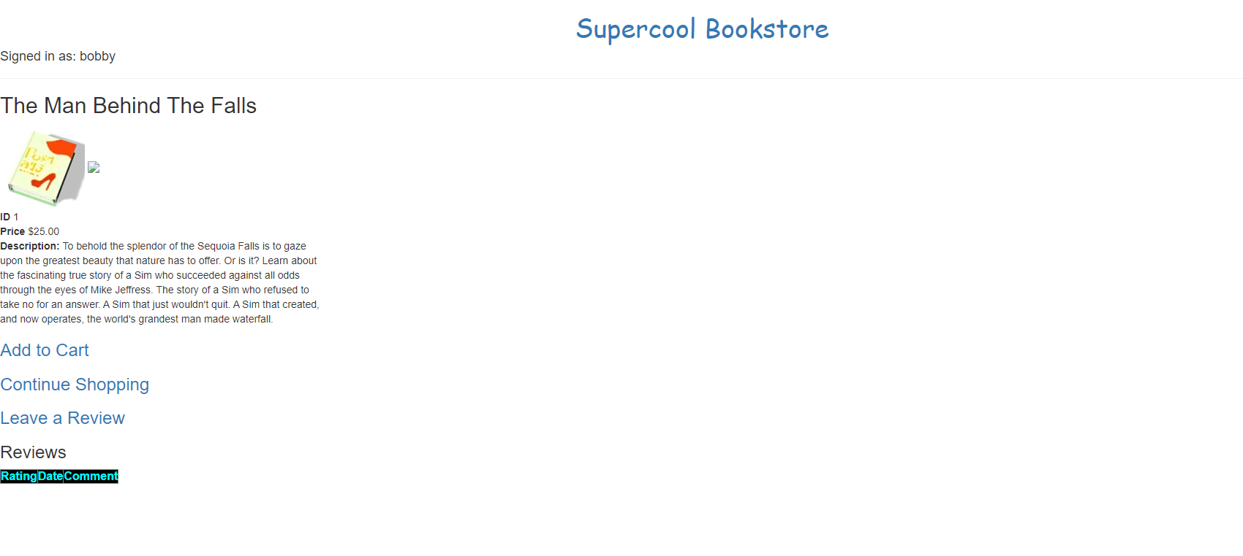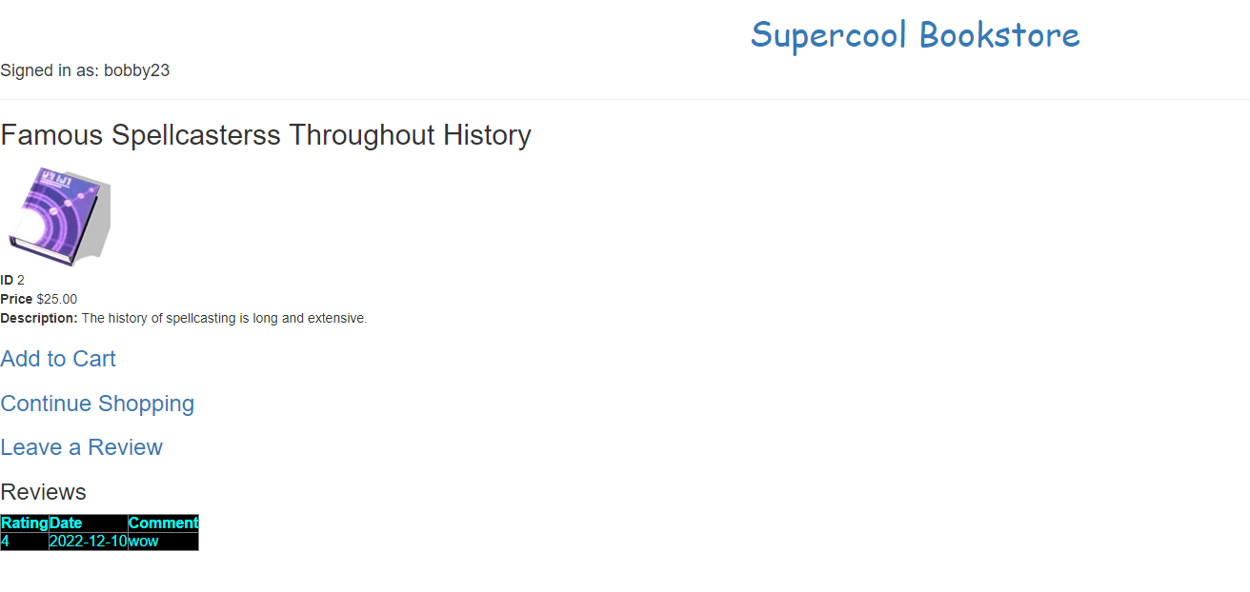

If you choose to leave a review, click on the ‘Leave a Review’ button. After doing so, you are taken to another page where you can rate the book on a scale from 1 to 5 and also leave a comment where you can elaborate on what you thought of the book. You can then press the submit button to leave your review of the product and can return to the product page. If you have already left a review of a product before, the website will let you know that you have already left a review on that product and then you can return to the product page.

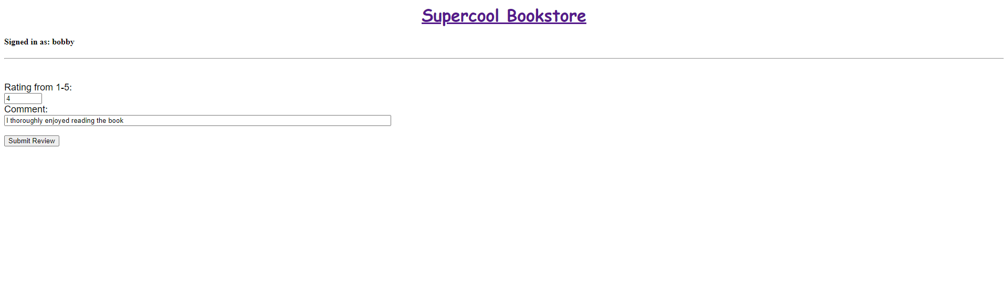  
If you click on the add to cart button instead of reviewing, you are taken to your cart and the item gets added to it. On the cart page, you can see all the items that are currently in your cart along with some information about the items. You have the option to increase or decrease the quantity of each item in your cart by pressing the plus or minus buttons. If you remove the last quantity of an item in the cart, the item is removed from the cart. Finally, the price for each item, as well as the total price is calculated and displayed.

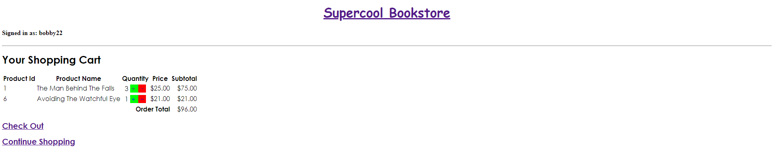

Upon adding too many items, the user is warned that there is insufficient stock and the check out button is hidden.

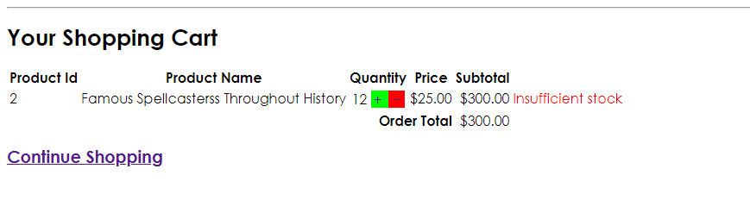

From here, you can either proceed to checkout or return to shopping. If you proceed to checkout, you are requested to input your customer ID and password for authentication, as well as shipment and payment information.

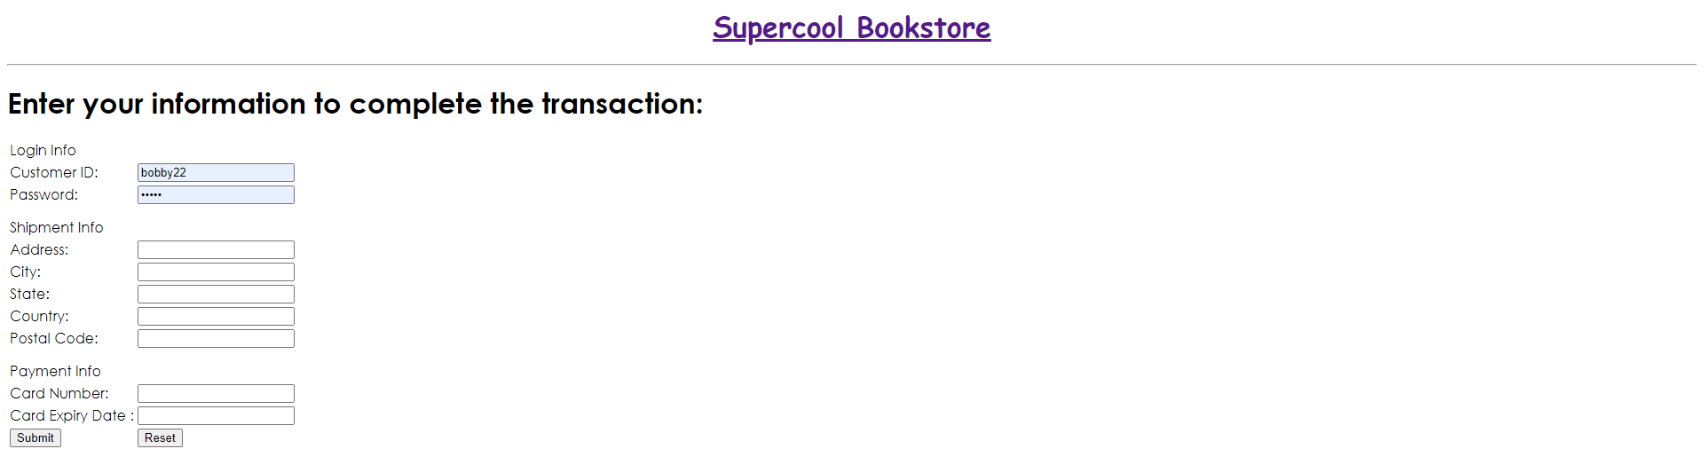

Once you enter the correct information, you are taken to the order summary page. This page shows the items that you have ordered, your reference number for the order, as well as the customer’s ID and name. If the user inputs an invalid userId, an error is shown. Finally, there is a button at the bottom to return to shopping.

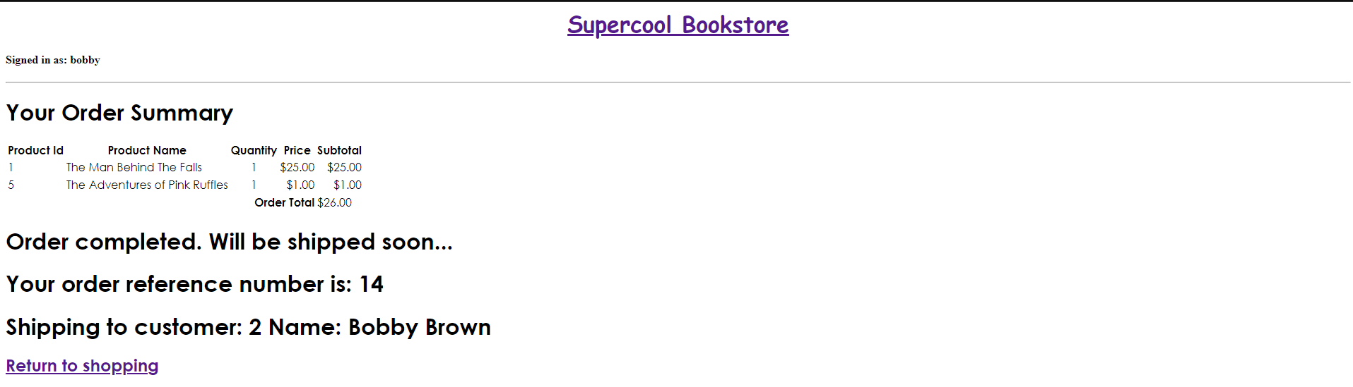

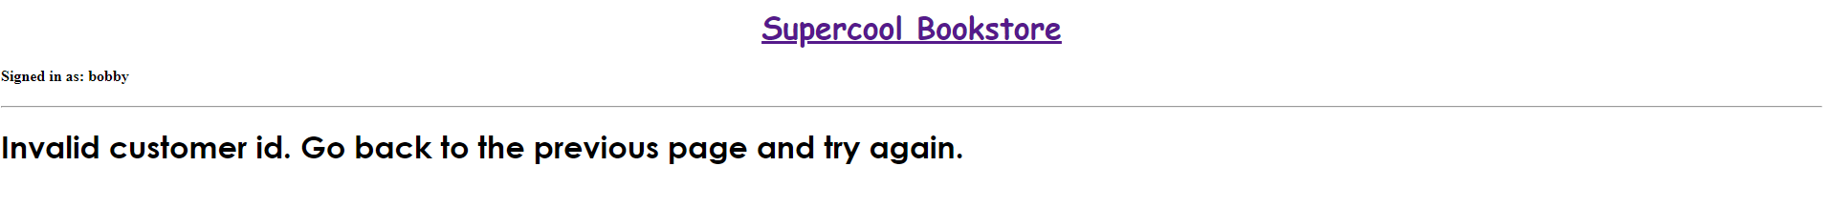

If you go back to the home screen and click on the ‘List All Orders’ button, you are taken to your order history page. Here you can see all the orders placed on the account you are currently logged in on. The order history shows you the order ID for each order along with the date and time the order was placed at. It also shows which items were purchased as well as the total price for each item.

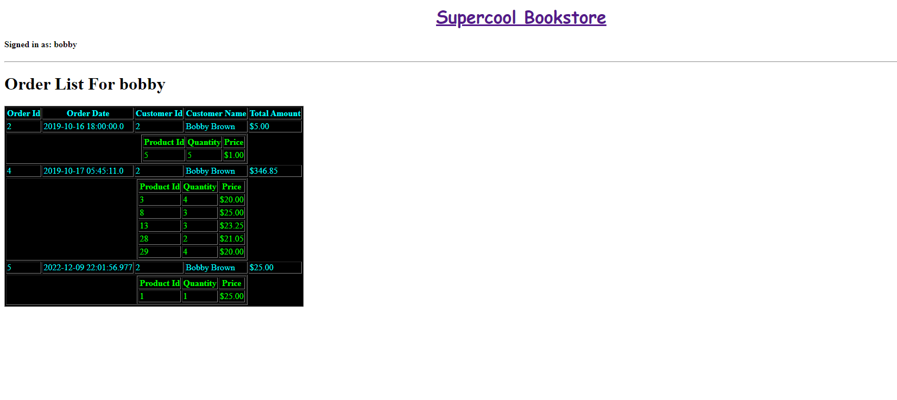

If you click on the ‘List All Orders’ button without being logged in, you can see the order list for every user combined into one.

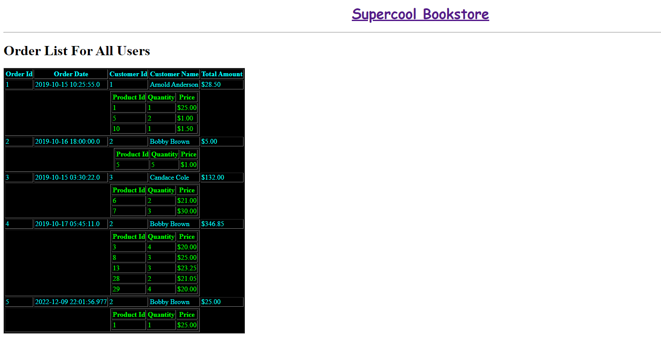

If you click on the ‘Customer Info’ button from the home screen, you are taken to a page where all of the user's information is listed such as their ID, name, email, phone, address and username.

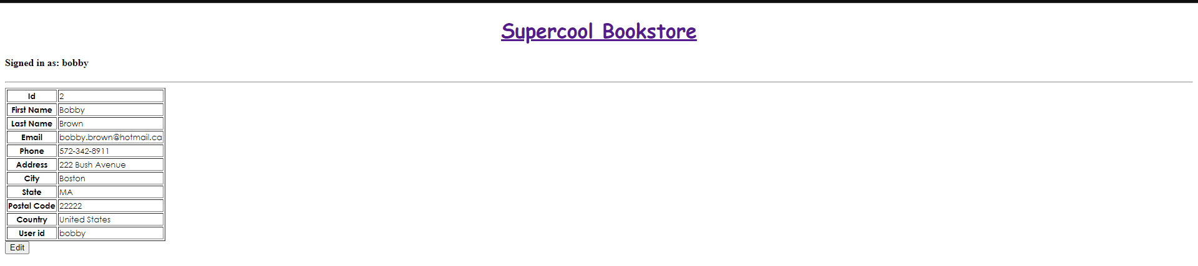

Upon clicking the ‘Edit’ button on the page, the users will be able to change their info.

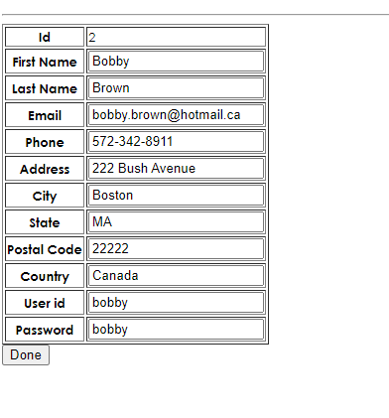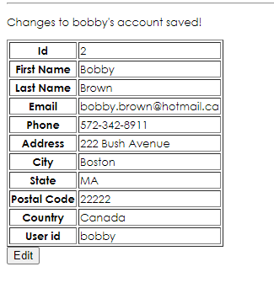

If the user tries to change their username to one already in use or they leave a field empty, they will get an error and be asked to try again.

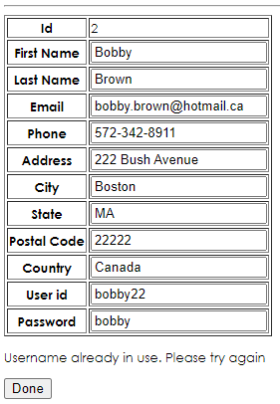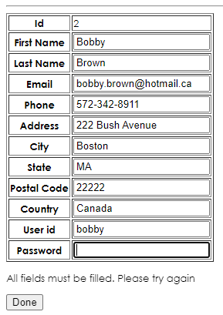

If you try and access the customer information page without being logged in, you are shown all customers.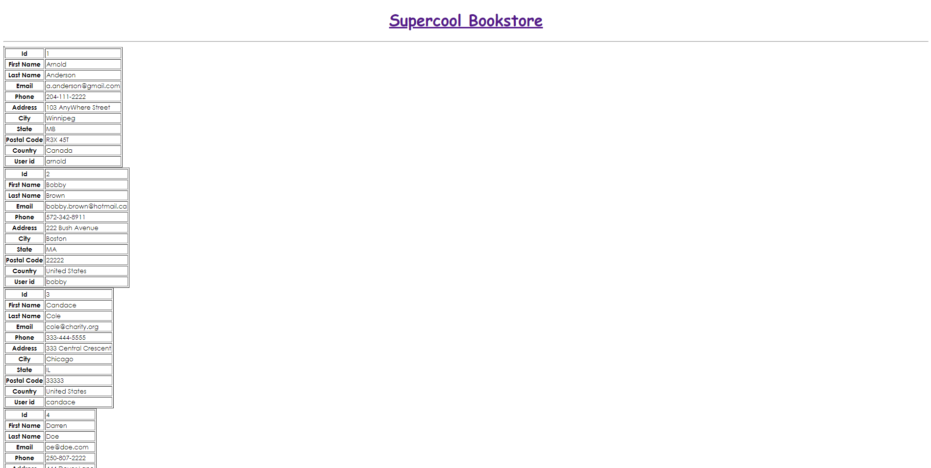

If you click on the ‘Administrators’ button from the home screen, you are taken to the administrator's page which shows the administrator's sales report by day. It lists a table with order dates and the total order amount being the columns.

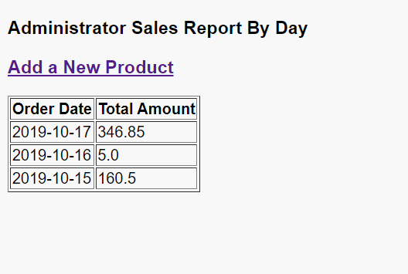

The page also shows the option to “Add a New Product”

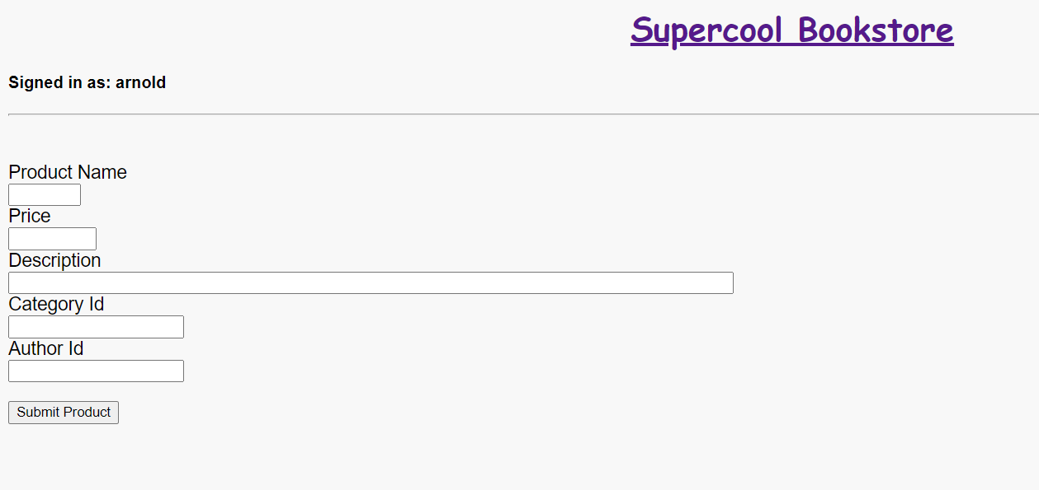

Once clicked you can add the name, price, description, category id, and author id to add a new book to the shop.

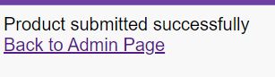

Once filled out and submitted, you will be redirected to a confirmation page. From there you can go back to the main admin page.

Finally, the logout button on the home screen simply logs the user out of their account. The user must log back into their account if they wish to place an order again.